Your Wheel of Life

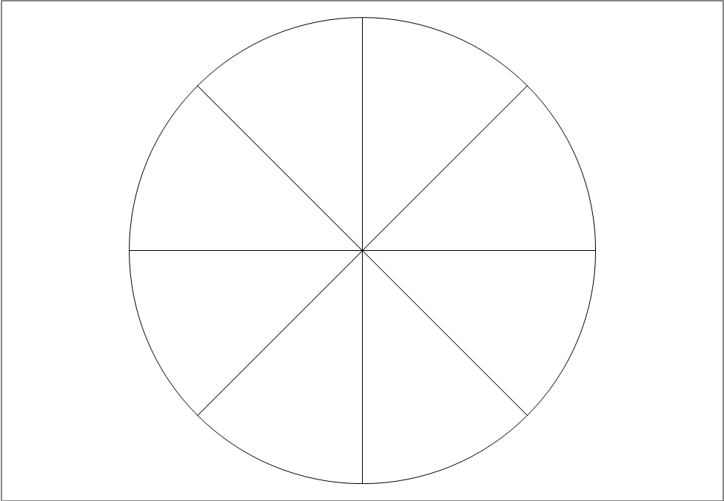
Career
Finance
Peronal Development
Family & Friends
Your surroundings
Fun & Recreation
Health
Romance

Start from the centre and work your way out in each segment. Mark each spoke 1-10 like marks on a ruler. The centre is where you are totally dissatisfied with your life, 10 on the outer rim where you are totally satisfied and 5 in the middle where things are OK but could be better. Complete Your Wheel of Life

